Measurement Tools
# Source: AI Source: Provided by: [Data Path: Persons Table -> ID Column: 1, Name_En Column: Motasem Essam] -> From: [ChatGPT] on [7/17/2026]
Measurement Tools are simple devices or implements used to measure physical quantities, usually through direct observation or manual reading. They are generally mechanical, require little or no electronic components, and are used for everyday, educational, industrial, and laboratory measurements.
Measurement tools are often considered a subset of measuring instruments, although the term usually refers to simpler, manual devices.

Definition
# Source: AI Source: Provided by: [Data Path: Persons Table -> ID Column: 1, Name_En Column: Motasem Essam] -> From: [ChatGPT] on [7/17/2026]
A Measurement Tool is a manual or simple device used to determine the size, quantity, dimension, or magnitude of a physical property by comparing it with a standardized scale or reference.
Unlike many measuring instruments, measurement tools typically do not contain complex sensors, electronics, or automatic data processing.

Purpose
# Source: AI Source: Provided by: [Data Path: Persons Table -> ID Column: 1, Name_En Column: Motasem Essam] -> From: [ChatGPT] on [7/17/2026]
Measurement tools are used to:
- Measure physical quantities.
- Compare dimensions.
- Verify sizes.
- Perform routine measurements.
- Support construction and manufacturing.
- Assist in scientific experiments.
- Improve accuracy in everyday tasks.

Characteristics
# Source: AI Source: Provided by: [Data Path: Persons Table -> ID Column: 1, Name_En Column: Motasem Essam] -> From: [ChatGPT] on [7/17/2026]
A good measurement tool should be:
- Accurate.
- Durable.
- Easy to use.
- Clearly marked.
- Stable.
- Portable.
- Properly calibrated when required.

Common Types of Measurement Tools

Length Measurement Tools
# Source: AI Source: Provided by: [Data Path: Persons Table -> ID Column: 1, Name_En Column: Motasem Essam] -> From: [ChatGPT] on [7/17/2026]
Examples:
- Ruler
- Measuring tape
- Meter stick
- Folding rule
- Surveyor's tape

Precision Dimension Tools
# Source: AI Source: Provided by: [Data Path: Persons Table -> ID Column: 1, Name_En Column: Motasem Essam] -> From: [ChatGPT] on [7/17/2026]
Examples:
- Vernier caliper
- Micrometer
- Feeler gauge
- Height gauge
- Depth gauge

Angle Measurement Tools
# Source: AI Source: Provided by: [Data Path: Persons Table -> ID Column: 1, Name_En Column: Motasem Essam] -> From: [ChatGPT] on [7/17/2026]
Examples:
- Protractor
- Combination square
- Bevel gauge
- Angle finder

Mass Measurement Tools
# Source: AI Source: Provided by: [Data Path: Persons Table -> ID Column: 1, Name_En Column: Motasem Essam] -> From: [ChatGPT] on [7/17/2026]
Examples:
- Beam balance
- Mechanical weighing scale
- Calibration weights

Volume Measurement Tools
# Source: AI Source: Provided by: [Data Path: Persons Table -> ID Column: 1, Name_En Column: Motasem Essam] -> From: [ChatGPT] on [7/17/2026]
Examples:
- Measuring cup
- Graduated cylinder
- Pipette
- Burette
- Volumetric flask

Temperature Measurement Tools
# Source: AI Source: Provided by: [Data Path: Persons Table -> ID Column: 1, Name_En Column: Motasem Essam] -> From: [ChatGPT] on [7/17/2026]
Examples:
- Mercury thermometer
- Alcohol thermometer

Pressure Measurement Tools
# Source: AI Source: Provided by: [Data Path: Persons Table -> ID Column: 1, Name_En Column: Motasem Essam] -> From: [ChatGPT] on [7/17/2026]
Examples:
- Mechanical pressure gauge
- Tire pressure gauge

Force Measurement Tools
# Source: AI Source: Provided by: [Data Path: Persons Table -> ID Column: 1, Name_En Column: Motasem Essam] -> From: [ChatGPT] on [7/17/2026]
Examples:
- Spring balance
- Mechanical dynamometer

Time Measurement Tools
# Source: AI Source: Provided by: [Data Path: Persons Table -> ID Column: 1, Name_En Column: Motasem Essam] -> From: [ChatGPT] on [7/17/2026]
Examples:
- Stopwatch
- Hourglass
- Mechanical timer

Classification
# Source: AI Source: Provided by: [Data Path: Persons Table -> ID Column: 1, Name_En Column: Motasem Essam] -> From: [ChatGPT] on [7/17/2026]
Measurement tools can be classified according to the quantity they measure.
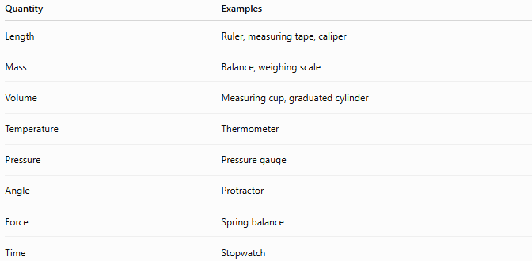
Quantity | Examples
Length | Ruler, measuring tape, caliper
Mass | Balance, weighing scale
Volume | Measuring cup, graduated cylinder
Temperature | Thermometer
Pressure | Pressure gauge
Angle | Protractor
Force | Spring balance
Time | Stopwatch

Mechanical vs. Electronic Tools

Mechanical Measurement Tools
# Source: AI Source: Provided by: [Data Path: Persons Table -> ID Column: 1, Name_En Column: Motasem Essam] -> From: [ChatGPT] on [7/17/2026]
Operate without electronics.
Examples:
- Ruler
- Measuring tape
- Vernier caliper
- Micrometer
- Beam balance

Electronic Measurement Tools
# Source: AI Source: Provided by: [Data Path: Persons Table -> ID Column: 1, Name_En Column: Motasem Essam] -> From: [ChatGPT] on [7/17/2026]
Include electronic components but are still commonly referred to as tools.
Examples:
- Digital caliper
- Laser distance meter
- Digital thermometer

Calibration
# Source: AI Source: Provided by: [Data Path: Persons Table -> ID Column: 1, Name_En Column: Motasem Essam] -> From: [ChatGPT] on [7/17/2026]
Many measurement tools require periodic calibration to ensure accuracy.
Examples:
- Micrometers
- Vernier calipers
- Measuring tapes used in precision work
- Laboratory balances
Calibration compares the tool with certified measurement standards.

Accuracy and Precision
# Source: AI Source: Provided by: [Data Path: Persons Table -> ID Column: 1, Name_En Column: Motasem Essam] -> From: [ChatGPT] on [7/17/2026]
Accuracy
How close the measured value is to the true value.
Example:
A ruler measures a rod as 50.0 cm when its true length is 50.0 cm.

Precision
How consistently repeated measurements agree with one another.
Example:
Repeated measurements:
50.01 cm
50.00 cm
50.02 cm
These measurements are highly precise.

Applications
# Source: AI Source: Provided by: [Data Path: Persons Table -> ID Column: 1, Name_En Column: Motasem Essam] -> From: [ChatGPT] on [7/17/2026]
Measurement tools are widely used in:
- Construction
- Engineering
- Manufacturing
- Carpentry
- Metalworking
- Education
- Science laboratories
- Healthcare
- Surveying
- Home improvement

Everyday Examples
# Source: AI Source: Provided by: [Data Path: Persons Table -> ID Column: 1, Name_En Column: Motasem Essam] -> From: [ChatGPT] on [7/17/2026]
Common measurement tools include:
- School ruler
- Tailor's measuring tape
- Kitchen measuring cup
- Kitchen scale
- Thermometer
- Tire pressure gauge
- Carpenter's square
- Protractor

Advantages
# Source: AI Source: Provided by: [Data Path: Persons Table -> ID Column: 1, Name_En Column: Motasem Essam] -> From: [ChatGPT] on [7/17/2026]
Measurement tools:
- Simple to use.
- Portable.
- Cost-effective.
- Reliable.
- Require little maintenance.
- Suitable for many everyday measurements.

Limitations
# Source: AI Source: Provided by: [Data Path: Persons Table -> ID Column: 1, Name_En Column: Motasem Essam] -> From: [ChatGPT] on [7/17/2026]
Measurement tools may:
- Have lower accuracy than advanced measuring instruments.
- Be affected by user reading errors.
- Require manual interpretation.
- Wear over time.
- Need periodic calibration for precision work.

Common Mistakes
# Source: AI Source: Provided by: [Data Path: Persons Table -> ID Column: 1, Name_En Column: Motasem Essam] -> From: [ChatGPT] on [7/17/2026]
- Using the wrong measurement tool for the required precision.
- Reading scales incorrectly (parallax error).
- Using worn or damaged tools.
- Ignoring calibration requirements.
- Measuring outside the tool's intended range.

Key Points
# Source: AI Source: Provided by: [Data Path: Persons Table -> ID Column: 1, Name_En Column: Motasem Essam] -> From: [ChatGPT] on [7/17/2026]
- Measurement tools are simple devices used to measure physical quantities.
- Most are manual or mechanical, although some may be electronic.
- They are widely used in education, engineering, manufacturing, laboratories, and daily life.
- Their performance depends on accuracy, precision, proper use, and calibration.
- They provide the practical means for obtaining reliable measurements in countless applications.

Measurement Tools vs. Measuring Instruments
# Source: AI Source: Provided by: [Data Path: Persons Table -> ID Column: 1, Name_En Column: Motasem Essam] -> From: [ChatGPT] on [7/17/2026]
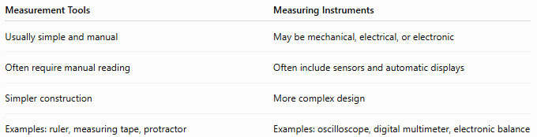
Measurement Tools | Measuring Instruments
Usually simple and manual | May be mechanical, electrical, or electronic
Often require manual reading | Often include sensors and automatic displays
Simpler construction | More complex design
Examples: ruler, measuring tape, protractor | Examples: oscilloscope, digital multimeter, electronic balance

Measurement Tools vs. Measurement Standards
# Source: AI Source: Provided by: [Data Path: Persons Table -> ID Column: 1, Name_En Column: Motasem Essam] -> From: [ChatGPT] on [7/17/2026]
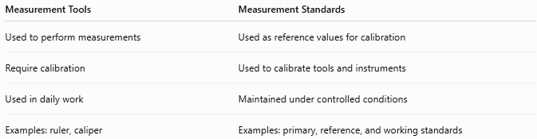
Measurement Tools | Measurement Standards
Used to perform measurements | Used as reference values for calibration
Require calibration | Used to calibrate tools and instruments
Used in daily work | Maintained under controlled conditions
Examples: ruler, caliper | Examples: primary, reference, and working standards

Measurement Tools vs. Sensors
# Source: AI Source: Provided by: [Data Path: Persons Table -> ID Column: 1, Name_En Column: Motasem Essam] -> From: [ChatGPT] on [7/17/2026]
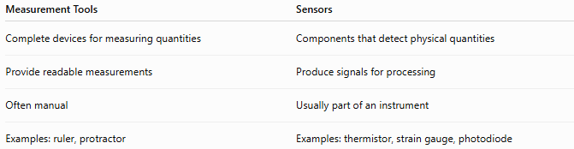
Measurement Tools | Sensors
Complete devices for measuring quantities | Components that detect physical quantities
Provide readable measurements | Produce signals for processing
Often manual | Usually part of an instrument
Examples: ruler, protractor | Examples: thermistor, strain gauge, photodiode

Conclusion
# Source: AI Source: Provided by: [Data Path: Persons Table -> ID Column: 1, Name_En Column: Motasem Essam] -> From: [ChatGPT] on [7/17/2026]
Measurement Tools are simple devices used to measure physical quantities by direct observation or comparison with standardized scales. They include tools such as rulers, measuring tapes, calipers, micrometers, balances, thermometers, protractors, and measuring cups. While generally simpler than advanced measuring instruments, they remain essential in science, engineering, manufacturing, construction, education, healthcare, and everyday life. When properly selected, maintained, and calibrated, measurement tools provide accurate, reliable, and practical measurements for a wide variety of applications.

